|  |  |
| --- | --- |
| **Name** | Muhammad Arslan Raza |
| **Section** | A |
| **Roll no.** | 2020-EE-403 |

**Lab 6**

**Experiment no. 5**

**DEMONSTRATION OF THE WORKING OF**

**AIR CONDITIONER CYCLE**

**Introduction:**

“Air conditioning is the process of removing heat and moisture from the interior of an occupied space to improve the comfort of occupants.”

This warming and cooling of the air is usually referred to as winter and summer air conditioning. An air conditioner collects hot air from a given space, processes it within itself with the help of a refrigerant and a bunch of coils and then releases cool air into the same space where the hot air had originally been collected. This is essentially how all air conditioners work. Air conditioners are basically refrigerators whose refrigerated space is a room or a building instead of the food compartment. A window air conditioning unit cools a room by absorbing heat from the room air and discharging it to the outside. The same air-conditioning unit can be used as a heat pump in winter by installing it backwards. In this mode, the unit absorbs heat from the cold outside and delivers it to the room. Air-conditioning systems that are equipped with proper controls and a reversing valve operate as air conditioners in summer and as heat pumps in winter. There are four components of air conditioning cycle. These four majors’ components are divided into two difference pressure: high pressure and low pressure. The high-pressure side is the condenser units (outdoor) and the low-pressure side is the air conditioning evaporator (indoor). The divided point between high and low pressure cut through the compressor and the expansion valve.

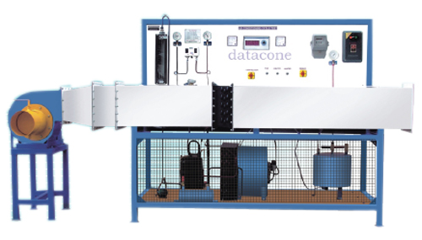

Figure 1:model of air conditioner

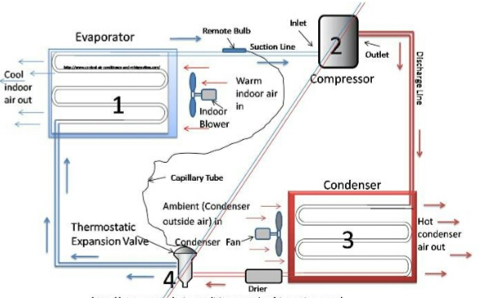

**Parts Lists:**

An air conditioning system consists of five mechanical components:

* Compressor
* Expansion valve
* Condenser Coil (Hot)
* Evaporator Coil (Cool)
* Refrigerant(dichlorofluoromethane)

**Working of Parts:**

**Explanation:**

The **inside unit** is normally inside the house somewhere, in the attic, basement, closet or crawl space. The **outside unit** is normally located on the side or back of the building. When air flows over the cold coils, heat from the air gets transferred to the refrigerant inside the coils. After the air flows over the coils, it gets cold.

* 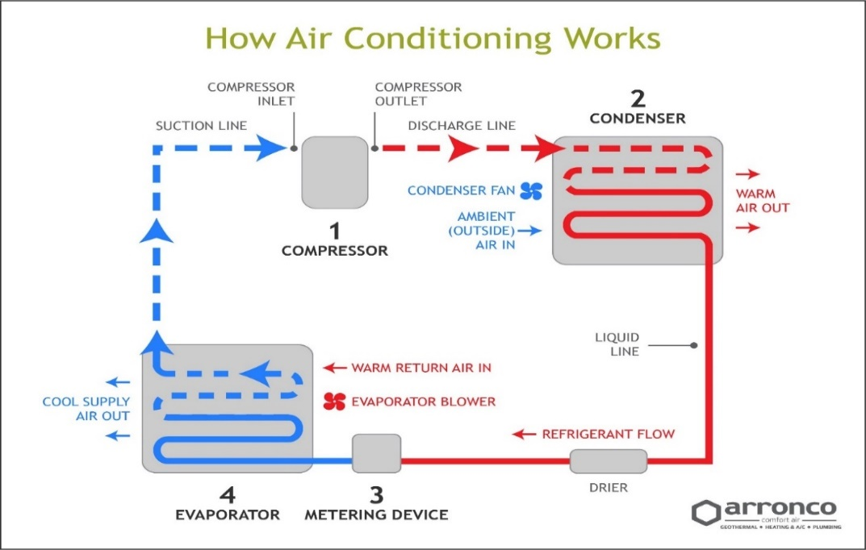This process follows the **2nd law of thermodynamics**, which says that heat naturally (spontaneously) flows from a warmer body to a cooler body.

After the refrigerant absorbs the heat, its state changes from a liquid to a vapor. This warmer refrigerant gas then gets transferred to the compressor. Even though the refrigerant has absorbed heat from the indoor air, it is still fairly cool. The still cool, but warmer vaporized gas enters the compressor (located in the outside unit) to increase its pressure and temperature. We increase the temperature of the refrigerant because it needs to be warmer than the outdoor air. Since the refrigerant has been compressed (pressurized), it is now hotter than the outdoor air. A condenser fan blows hot outdoor air, heat is removed from the refrigerant and released into the outdoor air. Again, this is due to the 2nd law of thermodynamics. After the refrigerant loses thermal energy to the outdoor air, it condenses back into a liquid and gets pumped back inside. When the refrigerant leaves your outdoor condenser unit, its temperature is still pretty high. The refrigerant’s temperature will need to drop significantly before it can absorb more heat from the indoor air.The metering device, usually a thermostatic expansion valve, is a special device that depressurizes the refrigerant, causing a drop in temperature. It does this by expanding the refrigerant into a larger volume. The refrigerant needs to be colder than the indoor air in order to absorb heat. Once the refrigerant gets cooled down, it flows back into the evaporator coils where it begins the cycle again.

Figure 2:Working of air conditioning cycle

**Working Diagrams:**

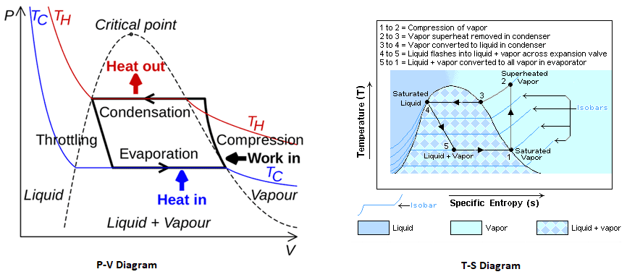

Figure 3:P-V and T-S Diagrams

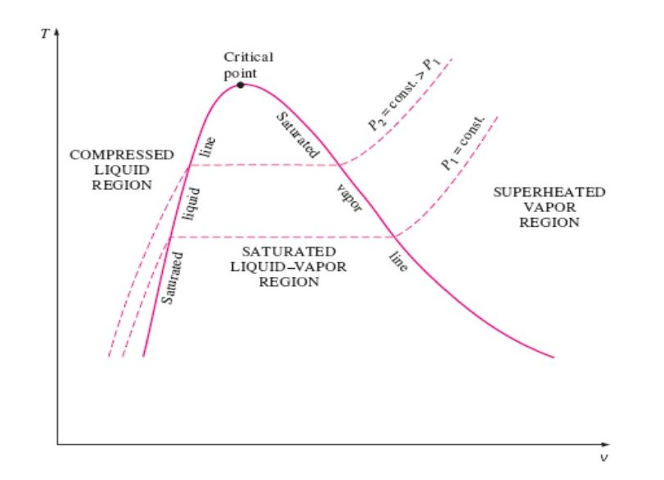

Figure 4:T-V diagram of air conditioning cycle

**1Ton AC:**

**12 thousand BTU=1 ton**

1000 Kg of ice at room temperature for 24 hours, cooling obtained will be known as 1 ton.

**Comparison Between AC and DC Inverter:**

There are two main types of inverter system:

* AC inverter
* DC inverter
* Basically, only the difference is the motor is driven by the inverter, not

the inverter device itself.

The inverter that drives an AC motor is called "**AC inverter**", and the

one which drives DC motor is called "**DC inverter**"

**Application:**

* Air conditioning (often referred to as AC, A/C, or air con) is the process of removing heat and moisture from the interior of an occupied space to improve the comfort of occupants.
* Air conditioning can be used in both domestic and commercial environments. This process is most commonly used to achieve a more comfortable interior environment, typically for humans and other animals; however, air conditioning is also used to cool and dehumidify rooms filled with heat-producing electronic devices, such as computer servers, power amplifiers, and to display and store some delicate products, such as art work.
* Air conditioners often use as a fan to distribute the conditioned air to an occupied space such as a building or a car to improve thermal comfort and indoor air quality. Electric refrigerant-based AC units range from small units that can cool a small bedroom, which can be carried by a single adult, to massive units installed on the roof of office towers that can cool an entire building. The cooling is typically achieved through a refrigeration cycle, but sometimes evaporation or free cooling is used.
* Air conditioning systems can also be made based on desiccants (chemicals which remove moisture from the air).
* Some AC systems reject or store heat in subterranean pipes. In addition to buildings, air conditioning can be used for many types of transportation, including automobiles, buses and other land vehicles, trains, ships, aircraft, and spacecraft.
* Commercial buildings, which are built for commerce, including offices, malls, shopping centers, restaurants etc.
* High-rise residential buildings, such as tall dormitories and apartment blocks.
* Industrial spaces where thermal comfort of workers is desired.
* Cars, aircraft, boats, which transport passenger or fresh goods.
* Institutional buildings, which includes government buildings, hospitals, schools etc.
* Low-rise residential buildings, including single-family houses, duplexes, and small apartment buildings.